In our first meeting, we discussed possible meeting times and days, as well as our overall project goal: achieving the smallest possible compression rate. Peter and David created rough code outlines and compared their data to determine which method provided better compression and efficiency. I completed and submitted the charter document. We then used a whiteboard to map out how our project would function. The algorithm will process the file of frequencies, and after testing three different prototypes, we combined the best aspects of each into one approach.

By the end of the meeting, we finalized our project direction and assigned roles:

* **Quentin** will create the presentation slideshow.
* **David and Peter** will focus on programming.
* **I** will handle meeting planning and documentation.

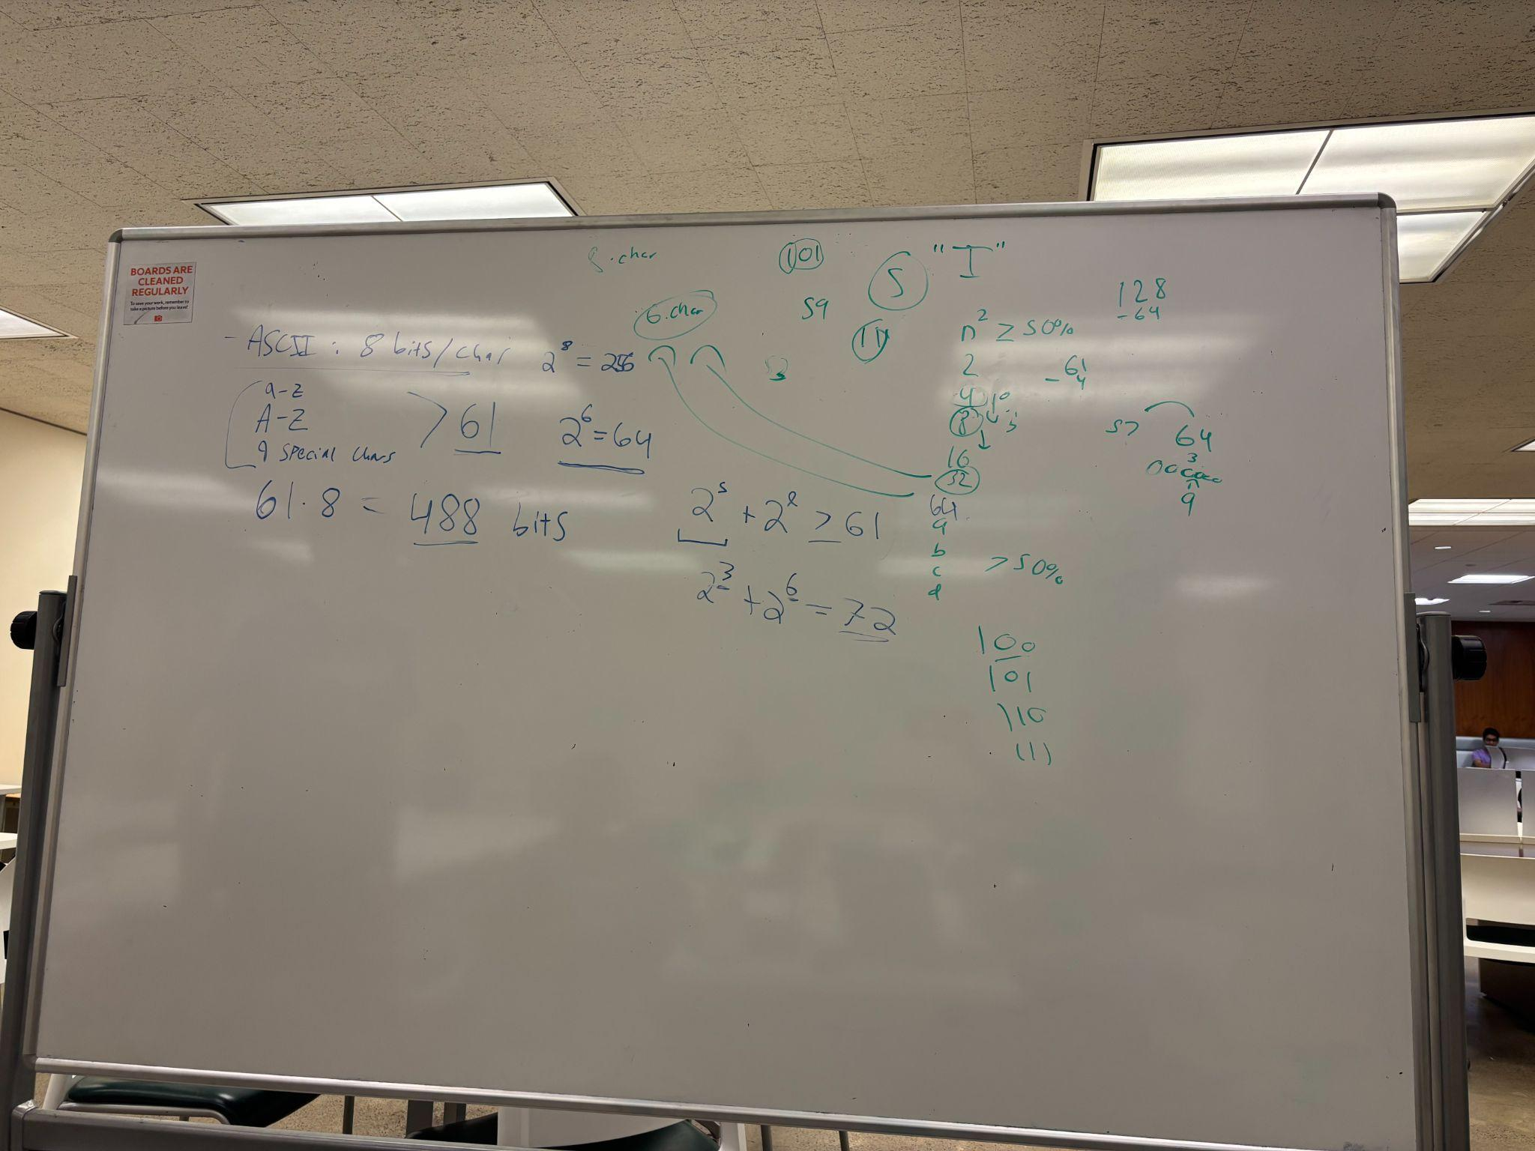

This is a rough outline of Peter and David explaining what their code outlines mean.

Meeting times.

Fridays at 3-4 @ Bird Library every week

Wednesday 12-2 @ Bird Library (only when we need to get more work done)

Meeting 2

Today is Friday, October 3rd, and we are at Bird Library. Peter, David, and maggie showed up. We changed our whole project because the original did not work. We are going to construct a fixed compression table. A function generates relevant frequencies in the file. Another function to generate the relative frequency of words. Waiting on a test text file from the daily orange from David, who will do math. Gives back a compression table which gives a translation between binary and the strings. Peter did a word that is defined as broken by white space and releases a ‘. words like “don't” or like, comma.

Meeting 3

Today is Wednesday, the 8th. We talked about the frequency generation. We plan to have extra spaces in our work. As well as words that go up to 11 characters. Peter is working on character and word generation. Peter has around 900 lines of code. The code is complete and should work. Since David just gave him a file to generate, Peter will run the code and then start debugging it. Peter wrote a binary, text, parent class, CSV. He ran the code, and it was successful. It is a CSV file. He generated the character frequency. Our current most frequent word is “the”. To conclude the meeting, we have successfully ran the code and it works and generates.

Meeting 4

We ran the code. We got a 40% reduction on the file. This is our final meeting before the project is due. We are talking about how we will submit the files. We are talking about how to run the file with the word commands. I sent an email in regards of the submission project.

To compress the file. ./main c (whatever the text file name is)

To decompress ./main d (whatever binary file name is)

The program is a predefined compression table off of many sample text. It compresses then decompresses. The table maps the string. The phrases are in the compression table. The most used phrases and symbols.